*Use the information in Chapter 24 (p.488-504) to complete the following questions/table. The following Bozeman podcasts may be helpful to watch before the reading:* [*Speciation*](http://www.bozemanscience.com/speciation) *and* [*Speciation & Extinction*](http://www.bozemanscience.com/007-speciation-and-extinction)*.*

1. Explain the relationship between speciation, microevolution, and macroevolution.

**Concept 24.1: The biological species concept emphasizes reproductive isolation**

1. Explain why the formation of a new species hinges on reproductive isolation.
2. Define and provide an example of the following barriers to reproduction

|  |  |  |  |
| --- | --- | --- | --- |
| **Type of Barrier** | | **Definition** | **Example** |
| Prezygotic | Habitat Isolation |  |  |
| Temporal Isolation |  |  |
| Behavioral Isolation |  |  |
| Mechanical Isolation |  |  |
| Gametic Isolation |  |  |
| Postzygotic | Reduced Hybrid Viability |  |  |
| Reduced Hybrid Fertility |  |  |
| Hybrid Breakdown |  |  |

1. What are the limitations of the biological species concept? Provide one example in which an alternative concept is needed to draw the line between different species.

**Concept 24.2: Speciation can take place with or without geographic separation**

1. Compare and contrast allopatric and sympatric speciation by completing the below table. Be sure to include their mechanisms as well as at least one example of each.

|  |  |  |
| --- | --- | --- |
| **Allopatric Speciation** | **Both** | **Sympatric Speciation** |
|  |  |  |

**Concept 24.3: Hybrid zones reveal factors that cause reproductive isolation**

1. Use the diagram below to explain how a hybrid zone forms as well as the possible outcome for hybrids. Provide an example of a population that this this is observed in.

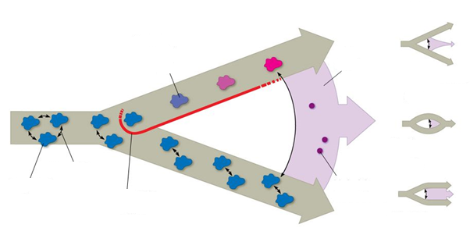

**Concept 24.4: Speciation can occur rapidly or slowly and can result in few or many changes in genes**

1. Use the diagram below to explain the two different patterns and rates of speciation. Be sure to provide an example for each.

